**P1- Puzzle Game Project**

**Purpose:**

Make People Think

**Goal Statement:**

Create a puzzle game with a story narrative.

**Objectives**:

1. Must have the player ask or be asked a question.
2. The game must have a definitive ending.
3. The game must start easy enough to not get dropped right away.
4. The game must provide multiple choices.

**12 Restriction Template**

1. Mouse controls only.
2. The game must be 2D.
3. The game must be turn-based (no real-time elements)
4. The game must be only single-player.
5. The art should be very simplistic
6. One or two-screen gameplay
7. Limited Animation
8. Open Source
9. Should focus on text
10. Built using Unity or Unreal Engine
11. No Player Customization
12. No tutorial
13. No offensive language or cursing words

**Strengths**

What area do you feel confident in?

Programmer:

* Bastien Auxer - Unity, Unreal, C++, C#, Java
* Jugemu - C#/Unity
* Cep - C#, Javascript/Typescript
* Tenise - C++, C#, Unity, Unreal
* Takumi_panda - C/C++, C#, Unity, Visual Studio Code
* MotH - C#, Unity, Godot(GDScript), Javascript/Typescript

Animator:

* Bastien Auxer - 3D
* Tenise - 2D
* Echo

Artist:

* Tenise
* Echo
* C.sam - 3D
* DSingh

Music & Sound:

* Loukas Drivas - Wwise, Foley, 8-bit, Ambient, a
* Aza - Editing, foley

Story Writer:

* Bastien Auxer
* Loukas Drivas
* DSingh
* Aza
* Takumi_panda

**Availability**

World Time Buddy:<https://www.worldtimebuddy.com/?pl=1&lid=5,121,122,6,30&h=5&hf=1>

Bastien Auxer:

* Time Zone: EST
* Time available: 12 pm - 5 pm
* Acting as a guiding hand from 8th through 10th

Loukas Drivas:

* Time Zone: GMT +2
* Time available: 1 pm - 4 pm, 7 pm - 10 pm

Tenise:

* Time Zone: CST
* Time Available: 10 am - 4 pm
* Mon - Friday

Cep:

* Time Zone: GMT+1
* Time available:
  + 03.01 - 07.01: 8am - 11pm
  + 08.01 - 11.01: 6pm - 11pm
  + 12.01 - 14.01: 8am - 11pm

Sam Coates (C.sam)

* Time Zone: CST
* Mon-Thur all-day
* Sun all-day

DSingh

* Time Zone: EST
* Tues-Fri : 12pm - 3pm

Takumi_Panda

* Time Zone: PST
* Mon-Sat: After meeting - 12pm (<t:1704830400:T>)
* Sun: After 10am (<t:1704218400:T>), depends on days.

Echo

* Time Zone: EST
* Time available: Weekdays: 12pm - 5pm (subject to change)
* Weekends: ?

MotH

* Time Zone: CEST (GMT+1)
* Time available: 4pm - 12pm

Aza

* Time Zone: EST
* Time available: Mon-Tues 8AM-12PM, 7PM On, Wed-Thur 8AM-11AM, 7PM on, Friday 6PM on, Weekends All Day typically

**Game Ideas**

Bastien Auxer: Mother of the End

* The last survivor of humanity

* Only a spirit.

* Technological computer

* Solve puzzles to lead to one of two fates

* Humanity lives

* Humanity dies

* Ask questions on what makes humanity good or bad

Tenise:

* The Game Follows a Storyline where players' decisions decide the events and end of the game. (Similar to Life is Strange)
* AI guides the player through the major events that caused the end of humanity.
* The player has to make the correct decisions and solve puzzles during the event that will determine whether to save humanity or not.

Loukas Dri:

- You are in a room full of furniture. When you move, every piece of furniture moves too. You need to find the pattern so the road to the door is opened. Between each room you will find an NPC who will share important details of the story.

- You start as a straight line. You need to fit the line in holes in order to unlock new rooms. Through your journey you find more lines with which you combine creating new shapes that need to fit in the appropriate holes.

- You are in a space station. You are an employee for a company that is responsible for keeping certain civilizations alive or not. The company exists in a place where people can see different dimensions from humans .Thus, they have the ability to see how choices affect the future. But they cannot see everything. When a civilization reaches a critical state, they are able to see some outcomes but they do not know how to achieve them. Here is where the player comes.The employees need to figure out the right paths in order to save the humans through a computer programme called F.A.T.E. You as a player are contacted by a spirit from earth. This spirit will make its appearance at the beginning of the game through the player's dream and guide them through their journey. The next speech will appear in the dream

* Some people tend to believe there are parallel universes where every different choice you would make takes place.
* So many different choices, so many paths.
* What about this universe?
* Are you taking the choices you want?
* Or believe they are good for you?
* For humanity?

Don't waste this chance.

Please.Save us. We didn't take..the right choices

Hey, you are finally awake. How did you sleep?

1. I had a great sleep

2. I had a terrible dream

3. I really don’t know.--->Ooook..Well good morning champ. We have a-lot of work to do. Especially in that place called earth.

In case of 2–>Aah don’t think too much about it. We have been here for quite some time.

1. How long has it been, again? –>109 years→ Oh..yeah

2. Yeah..Too long

In case of 1, 2 Well good morning champ. We have a-lot of work to do. Especially in that place called earth.

At the end of each conversation your female coworker says:

They told us many paths have been created and it is code red for earth. You need to get on it asap as I need to still take care of Proxima centauri D. Go to your F.A.T.E

Then you sit on your computer (in the spaceship) and start playing the actual game

Cep

* Game Name: "Should humanity be destroyed?"
* A game where the user is presented with multiple truthful statements that color the current human civilization in a negative/despairing light. The player must solve puzzles to progress from one statement to another. After progressing through some (e.g. 3) statements - the user is presented with a question if humanity should be destroyed? (based on information acquired from the statements). The game will deny the user the option to click `No` to reach the good ending until certain conditions are met.
* Approximate game loop graph:
* 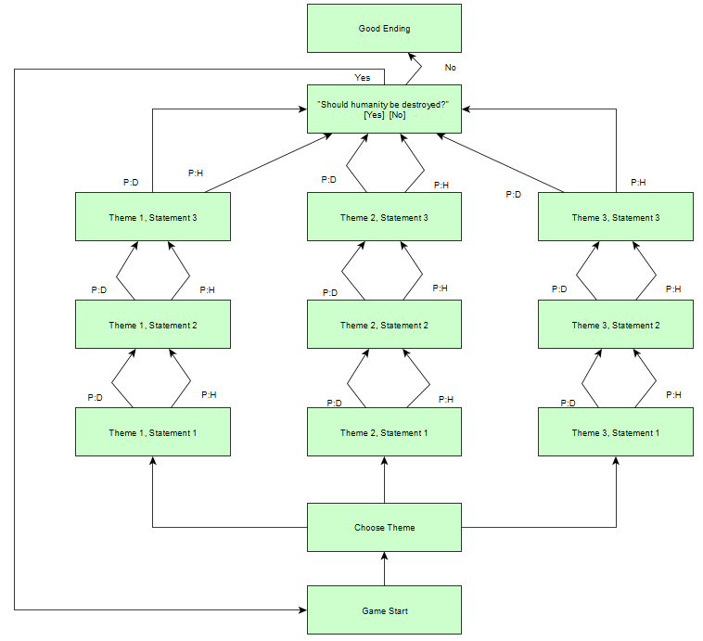
* Graph legend:
  + P:D - Puzzle solution - despairing
  + P:H - Puzzle solution - hopeful
* To reach the good ending - achieve hopeful solution for each Statement of each Theme

**Finalized Idea**

**Plot**: Should Humanity Be Saved?

**Mechanics**: Puzzles

* 2D platformer - FireBoy and Water Girl
* Ask questions - Life is Strange Style
* Worm to existence - Name based on Loukas Idea
* Room full of furniture - Loukas Idea

**Story Game Play**: See Graph from Cep

**Team and Game Name ideas:**

* Minds Conclusions Dissolutions M.C.D
* Conscious Conclusions Dissolutions
* Thoughts Conclusions Dissolutions
* Conclusions and Dissolutions
* Collective Dissolutions
* Conclusions Dissolutions

**Puzzle Ideas**

* Player is presented with a comic book. The images are randomized and the player needs to place them in order. The imagery represents a state of humanity.
* The player is exploring a platform level finding the pieces necessary to fix the problem or the pieces that will make the situation worse. Ex. The player is in a forest where activists are protesting while lumberjacks are destroying the forest to plant plam teams. The player has the choice to find tools that will help the protestors or find tools that help the workers. Players can find seeds to help create biodiversity or find gas to help fuel the worker's tools.After choosing who to help the result is shown in the background.
* Make a point and click adventure:
  + Expansion of the activists/lumberjecks puzzle
  + Go to lumberjacks side - pick up a bucket
  + Go to forest area - fill the bucket with water (e.g. from the lake)
  + Puzzle ending options:
    - Dump water on activists
    - Dump water on lumberjacks
    - Dump water on both
      * You don’t side with anyone, not denying any side
      * Both sides are cooled and united (against you, but you don’t case since you are a ghost >:) )

#### **1 Sentence pitch**

Follow the Last Human Consciousness being Guided by F.A.T.E. to relive the disasters that destroyed humanity, while building the perspective to determine if Humanity Should Live Again.

(Fully. Artificial. Thoughts. Engine.)

**Game end Ideas**

1. Depending on the percentage of good and bad. Changes the outcome of humanity.
   1. 100% Bad ⇒
      1. Sun is exploded… nothing but dust
      2. Sun turns into a black hole
   2. 100% Good == Utopia planet is formed
   3. 50/50 == Humanity is saved…. But we come back here again

**Statement/Question**

1. Humanity has caused the most environmental changes to the lands and nature through it’s wars and actions
   1. POS: Humanity has repaired most of its damage.
      1. Planting a tree
   2. CON: Humanity has yet to learn the effects of its actions.
      1. Pick up arms and fight